**WEEK 6**

**OPERATING SYSTEM IN PRACTICE**

**REMOTE SSH CONNECTION**

**Remote Connection** allows us to manage multiple machines from anywhere in the world.

There are several ways to connect to remote computers.

**1.SSH (Secure Shell)**

Secure Shell Protocol implemented by other program to securely access one computer from another.

* To use SSH, we need to have SSH server on.
* Keep in mind, SSH is just a software.
* On the remote machine SSH is running as a background process.
* It constantly checks if a client is trying to connect to it, then it will authenticate requests.
* Most popular program to use SSH within is Linux is OpenSSH program.
* In case of Windows, we use PuTTy (an open source program).

**Linux Command**

**SSH username@ IP address**

Two ways: one using cmd and pwd , other using SSH authentication.

SSH authentication has two keys:

* Private : You can unlock using it but not lock.
* Public : You can lock using them but not unlock.
* This maintains security and integrity.

**2.Virtual Private Network**

* VPN is another way to connect to remote systems.
* It is the number of computers connected by a network. However, the basic idea of the VPN is that it is not a real network such as the Internet; it is a virtual one. “Virtuality” here is very important.
* It allows us to connect to a private network like we do over internet.
* It allows us to share resources like shared file servers and network devices if we are connected to work network.

**3.Remote Connections in Windows**

**PuTTy**

* Putty is a free open source software that you can use to make remote connections through several networking protocols such as SSH.

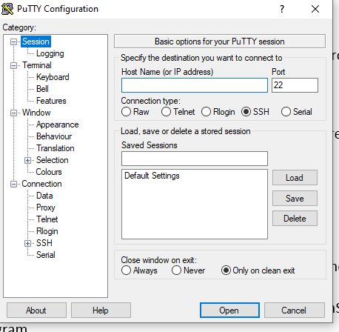

* Two ways to access Putty.

Download PuTTy. Connect through GUI.

Using Powershell putty.exe

-ssh username@ IPaddress

**4.Remote Desktop Protocol**

Remote Desktop Protocol provides users with a GUI to remote computers, provided remote computers has incoming RDP connections.

A client Program called **Microsoft Terminal Services Client or mstsc.exe** is used to create RDP connections to remote computers.

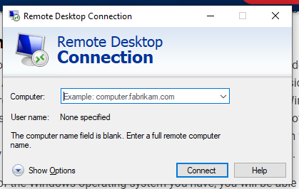

**Remote Connection File Transfer**

**SCP (Secure Copy)**

A command you can see in Linux to copy files between computers and a network.

It utilizes SSH to transfer data.

Ex.To copy over a file from over computers to another computers.

* PuTTy supports SCP Protocol.
* PuTTy package comes with a tool called PuTTy Secure Copy Client or pscp.exe.
* Command: **pscp.exe ~Filepath username @IP location to copy**

**Virtual Machines**

* A Virtual Machine (VM) is a compute resource that uses software instead of a physical computer to run programs and deploy apps. One or more virtual guest machines run on a physical host machine.

**Logging**

**System Monitoring**

Act of create log events is called logging.

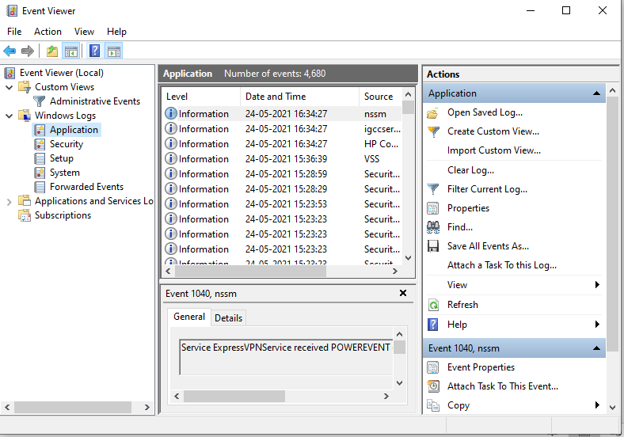

**Operating System Deployment Methods**

* **Disk Cloning Tool** makes a copy of an entire disk and allows you to back up a current machine or set up a new.
* Lots of disk cloning tools available.
* Benefit of disk cloning own a standalone installation media is that you can also install setting and folders you might need.
* One popular open source software of disk cloning tool is called CloneZilla.
* Dd is a light weight tool that’s used to clone a drive.